# Node basics:

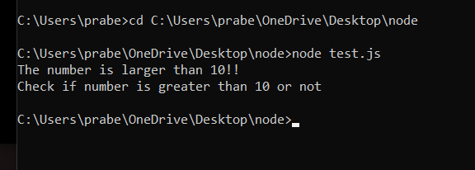

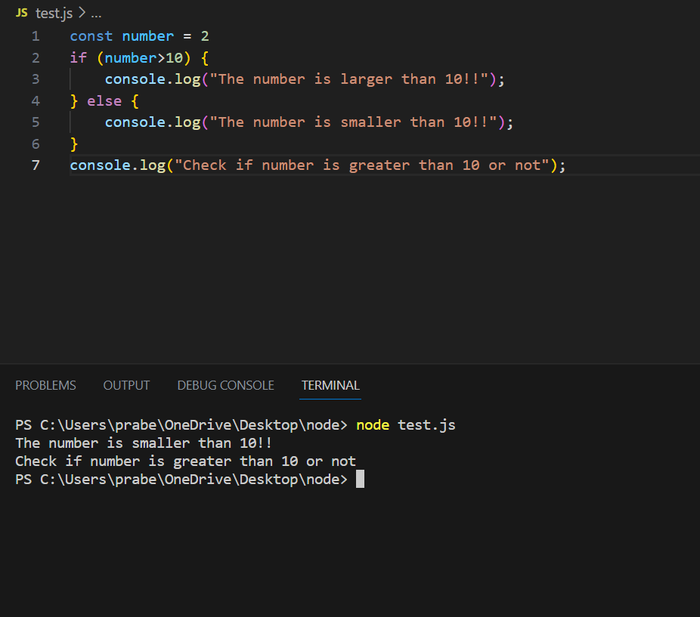

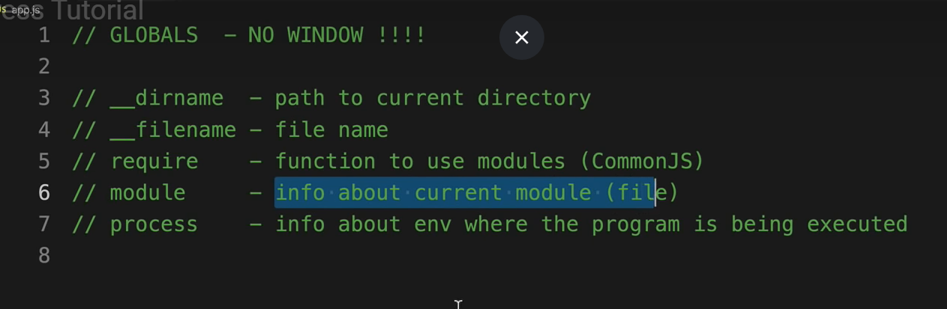

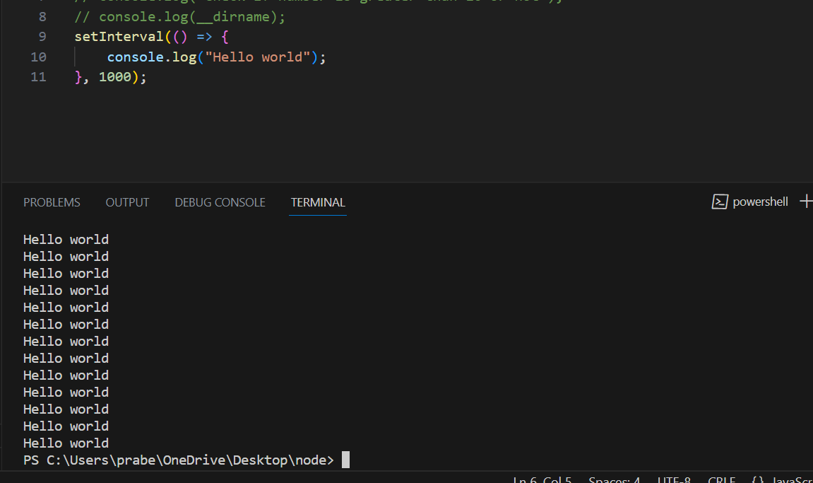

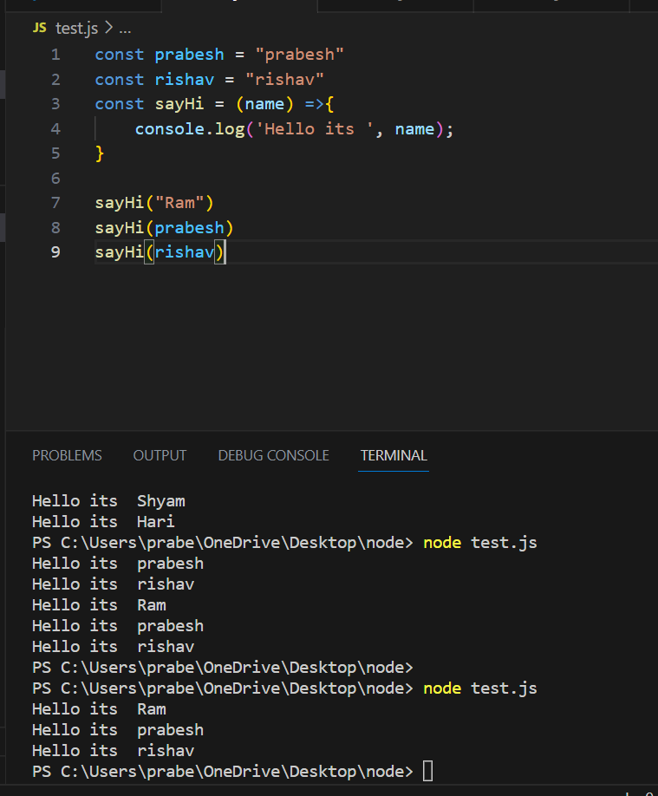

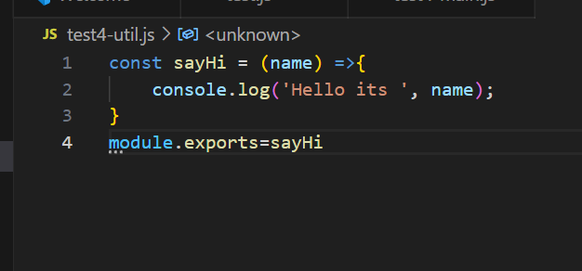

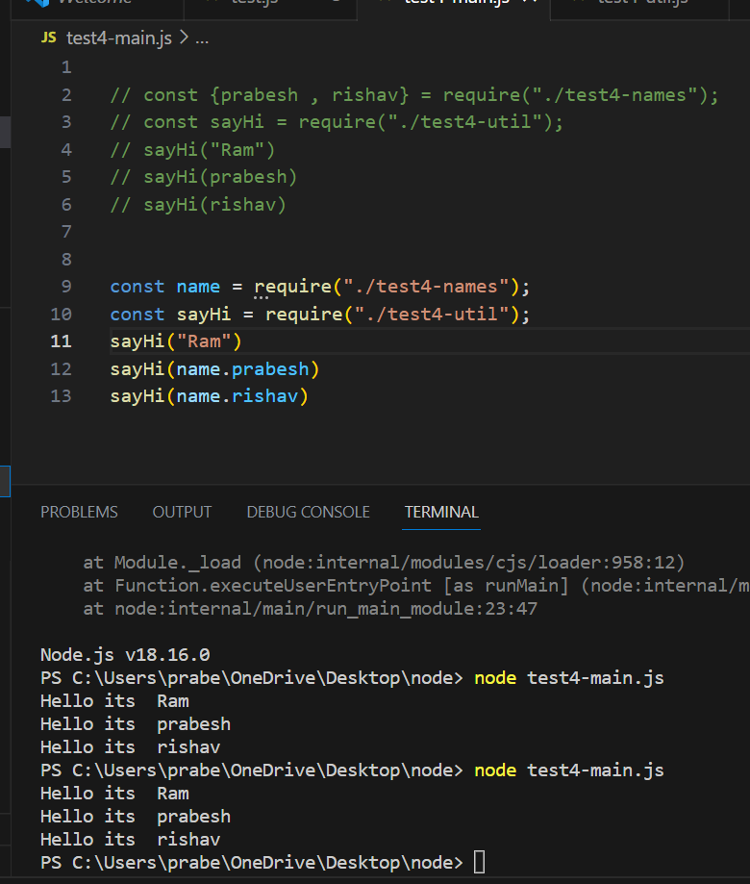

**Alternative method:**

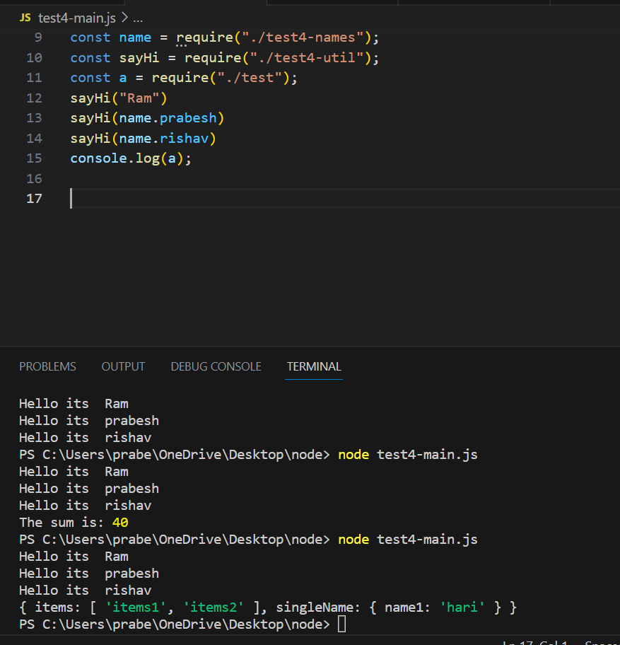

**Continuing (Calling function as module):**



